***CityCrave – Food Ordering App (User & Restaurant Panel)***

# **The domain of the Project:**

# G5 - UIUX

# **Team Mentors (and their designation):**

# Sir Sen Ghiri Sudhan

# UI/UX Designer - MetricStream

# **Team Members:**

Ms. Trupti Zaware

# **Period of the project**

# **July 2025 to December 2025**

Declaration

The project titled “CityCrave – Food Ordering App (User & Restaurant Panel)” has been mentored by Sir Sen Ghiri Sudhan, organised by SURE Trust, from July 2025 to December 2025, for the benefit of the educated unemployed rural youth for gaining hands-on experience in working on industry relevant projects that would take them closer to the prospective employer. I declare that to the best of my knowledge the members of the team mentioned below, have worked on it successfully and enhanced their practical knowledge in the domain.

Team Members:

Ms. Trupti Zaware

Signature

Mentor’s Name – Sir Sen Ghiri Sudhan

Designation- UI/UX Designer - MetricStream

Prof. Radhakumari

Executive Director & Founder

SURE Trust

Table of contents

1. Executive summary
2. Introduction
3. Project Objectives
4. Methodology & Results(Screenshots)
5. Learning & Reflection
6. Future Scope & Conclusion

***Executive Summary***

CityCrave is a food ordering platform designed for both customers and restaurant partners. The project covers end-to-end flows for both sides.

***Introduction***

Food delivery apps require smooth coordination between users and restaurants. CityCrave was designed to address this with separate yet connected interfaces.

***Project Objectives***

* Design user-friendly ordering flow
* Create efficient restaurant order management
* Ensure smooth communication between both sides

***Methodology and Results***

**User Flow:  
Login → Browse → Order → Payment → Tracking → History**

**Restaurant Flow:  
Login → Orders → Order Status → Menu Management**

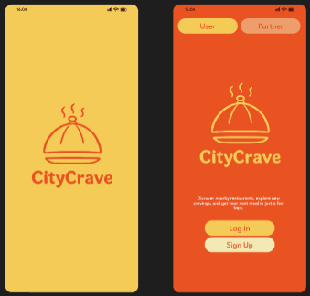

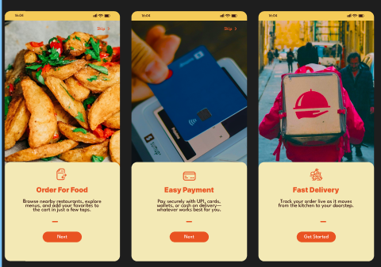

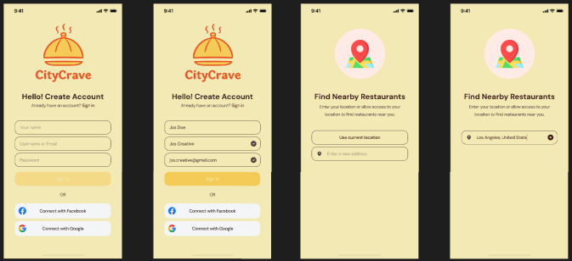

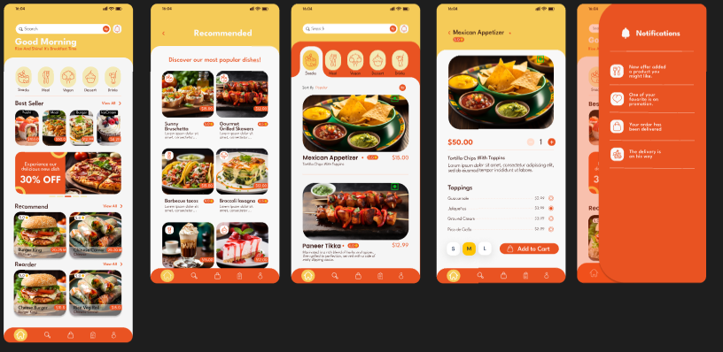

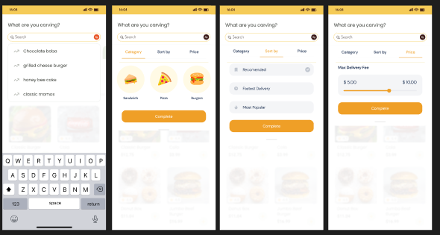

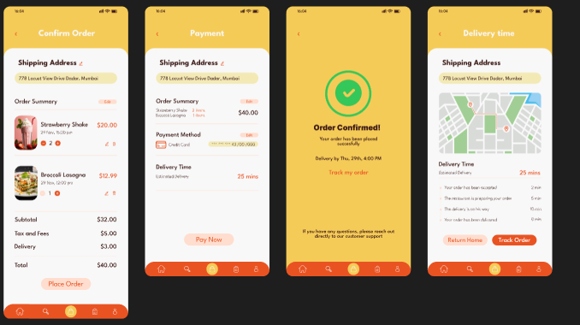

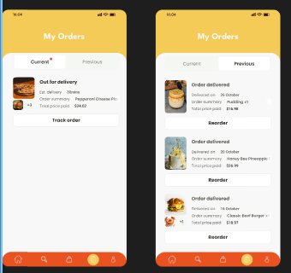

***Learning and Reflection***

Learned how to design multi-stakeholder platforms with different user needs.

***Conclusion and Future Scope***

Admin panel and analytics can be added in future.